

Submitted by**:**

**Ayesha Atta (BSMSA-23-05)**

Supervised by:

**Dr. Athar Kharal**

Centre for Advanced Studies in Pure and Applied Mathematics

Bahauddin Zakariya University, Multan

***Inventory Management and Prediction***

Optimizing stock levels using predictive analytics and Excel Model

A Project Report On

**Acknowledgement**

With hearts filled with gratitude, I begin by praising **Allah (SWT),** the Most Merciful, who endowed me with the strength, wisdom, and opportunity to complete this project.

To My **Respected Supervisor**, Dr. Athar Kharal, your scholarly guidance, meticulous feedback, and unwavering encouragement were the cornerstones of this work. I am eternally grateful for your mentorship.

To **CASPAM and Bahauddin Zakariya University**, thank you for providing the resources, infrastructure, and academic environment that nurtured this research.

To **My Family**, my parents, whose prayers and sacrifices are the foundation of my achievements, and my siblings, whose love kept me motivated this success is yours.

To **My Friends and Colleagues**, your camaraderie, insightful discussions, and moral support made this journey less daunting and more enriching.

To **All Who Supported Me**, whether through a kind word, a Dua, or silent encouragement your role is deeply cherished.

Finally, **To the Readers**,

May this work contribute meaningfully to the field, and May **Allah (SWT**) accept it as a sincere effort.

**Dedication**

This humble effort is dedicated with profound gratitude to the pillars of my life, whose unwavering support and blessings have illuminated my path.

**To My Beloved Parents,** your sacrifices, prayers, and boundless love have been my strength and inspiration. This achievement is as much yours as it is mine.

**To My Teachers,** you shaped my intellect with patience and wisdom, instilling in me a love for knowledge that transcends boundaries.

**To My Supervisor,** your guidance was a beacon of light, and your faith in my potential kept me steadfast in this journey.

**Above All, To Allah (SWT)**, The source of all wisdom and grace. Without His mercy, this accomplishment would not have been possible.

**Declaration by Candidate**

I, **Ayesha Atta**, declare that this project report, titled **“Inventory Management and Prediction using Microsoft Excel”**, is my own original work. Where I have used other sources, I have properly cited and referenced them as per my institution’s guidelines. I understand that plagiarism or presenting someone else’s work as my own can lead to serious consequences, including the cancellation of my degree. I further declare that this project report has not been submitted for any other degree or diploma in any other institution or university. I take full responsibility for the correctness, originality, and honesty of my work.

**Signature:**

Candidate:

**Ayesha Atta**

Roll No:

**BSMSA-23-05**

**Supervisor:**

Dr. Athar Kharal

**Certificate by Supervisor**

This is to certify that **Ayesha Atta**, a student of **BS-Mathematics at CASPAM**, has

successfully completed the project entitled **“Inventory Management and Prediction using Microsoft Excel”** under my supervisor. I have guided her throughout this project, and I am pleased with the quality of her work, which meets all the program’s requirements. I also confirm that the project work presented in this report is original and has not been submitted for any other degree or diploma in any other institution or university. I appreciate her hard work, dedication, and effort in completing this project.

**Signature:**

Supervisor:

**Dr. Athar Kharal**

Assistant Professor

CASPAM B.Z.U

**(Internal Examiner)**

**(External Examiner)**

**(In-charge Examiner)**

**Abstract**

This project focuses on improving **inventory management and sales prediction** using **Microsoft** **Excel**. The goal is to help businesses manage stock more efficiently by identifying which products matter most and predicting future demand based on past trends. The dataset includes 24 months of sales data for over 500+ products, with 3 months used for analyzing inventory and 9 months for forecasting.

In **Chapter 1**, we provide a general introduction to inventory management and explain why it's important for businesses to keep the right amount of stock—enough to meet customer needs but not so much that it increases storage costs.

In **Chapter 2**, we apply the **ABC Analysis model** in Excel. This technique classifies items into three categories: **A-items**: few in number but contribute the most to revenue, **B-items**: medium contribution, **C-items**: many items with the least impact. By using this method, we can prioritize which products should be monitored closely, helping to reduce waste and improve decision-making.

In **Chapter 3**, we develop a forecasting model using Excel functions and charts. We use past sales data to predict future product demand. This helps in planning purchases and avoiding stock-outs or overstocking. Excel formulas, such as moving averages, are used to build this prediction model, making it easy to use even for beginners. Overall, this project demonstrates how Excel can be a powerful and accessible tool for inventory analysis and demand forecasting. By combining ABC classification with basic forecasting, businesses can **save money, reduce risk, and improve customer satisfaction**.

**Keywords:** Inventory Management, Sales Prediction, ABC Analysis, Forecasting, Excel Modeling, Demand Prediction, Pareto Principle, Data Analytics.

***Table of Contents***

**Chapter.No.01: Introduction to Inventory Management and Prediction** 8

**1.1 Inventory** 8

**1.2 Importance of Inventory in Business** 8

**1.3 Inventory Management** 8

**1.4 Working of Inventory Management** 8

**1.4.1 Types of Inventory** 9

**1.4.2 Challenges in Inventory Management** 10

**1.5 Theoretical Models of Inventory Management** 10

**1.5.1 Economic Order Quantity (EOQ)** 10

**1.5.2 Just-in-Time (JIT)** 11

**1.5.3 Reorder Point (ROP)** 11

**1.5.4 ABC Analysis** 11

**1.6 Predictive Analytics in Inventory Management** 12

**1.7 Support of Predictive Analytics in Inventory Management** 12

**1.8 Role of Prediction in Inventory Management** 14

**1.9 Importance of Predictive Analytics** 14

**1.10 Introduction to the Model** 16

**1.11 Objective of the Model** 16

**1.12 Dataset Overview** 16

**1.13 Software Tool Used – Microsoft Excel** 16

**1.14 Benefits of the Project** 16

**Chapter.No.02: ABC Analysis Model Using Excel** 18

**2.1 ABC Analysis** 18

**2.2 Theory Behind ABC Classification** 18

**2.3 Use of ABC in Inventory** 18

**2.4 Mathematical Calculations in ABC Analysis** 18

**2.4.1 Revenue Calculation** 18

**2.4.2 Percentage of Revenue and Cumulative Percentage** 18

**2.4.3 ABC Classification Formulae** 19

**2.5 ABC Analysis Model Design** 19

**2.5.1 Introduction** 19

**2.5.2 Data Collection** 19

**2.5.3 Sales Forecasting and Data Preparation** 19

**2.5.4 Total Sales Column** 20

**2.5.5 ABC Analysis Strategy** 20

**2.5.6 Excel Steps and Key Formulas** 20

**2.5.7 Create Pivot Table** 21

**2.5.8 Pivot Table and Revenue Calculation** 22

**2.5.9 Calculating Percentage of Total Revenue** 24

**2.5.10 Calculating Cumulative Percentage** 25

**2.5.11 ABC Classification Formula** 26

**2.5.12 Creating and Analyzing the Line Chart** 28

**2.5.13 Summary of steps** 29

**Chapter.No.03: Results, Limitations, Comparison and Future work** 30

**3.1 Results of the Model** 30

**3.2 Purpose and Benefits (Why ABC Analysis)** 31

**3.2.1 Uses of ABC Analysis** 31

**3.2.2 Real-Life Example** 32

**3.3 How Model was Built** 32

**3.4 Insights from ABC Categories** 33

**3.4.1 A-Items (The VIP Products)** 33

**3.4.2 B-Items (The Steady Performers)** 33

**3.4.3 C-Items (The "Let It Go" List)** 33

**3.5 Limitations of the Model** 34

**3.6 Challenges & solutions** 35

**3.7 Accuracy and Improvement Areas** 36

**3.8 Comparison with Manual Inventory Methods** 37

**3.9 Comparison with Advanced Inventory Software** 39

**3.10 Future Work** 40

# **Chapter.No.01: Introduction to Inventory Management and Prediction**

## **1.1 Inventory**

**Inventory** refers to all the goods and materials a company keeps on hand to keep its business running—whether that means selling products, making new ones, or repairing existing ones. It usually includes raw materials, which are the basic parts or ingredients needed to create a product; work-in-progress items, which are currently being made but not yet finished; and finished goods, which are the final products ready to be sold to customers.

## **1.2 Importance of Inventory in Business**

Inventory plays a key role in keeping the supply chain running smoothly and making sure daily business operations go without a hitch. It’s closely linked to how satisfied customers are, how well costs are managed, and how efficiently a business run. When the right products are available at the right time, customers are more likely to be happy with their experience. Good inventory control also helps businesses cut down on unnecessary storage costs and manage their cash flow more wisely. Most importantly, having the right stock on hand ensures that orders can be fulfilled promptly, reducing delays and backorders that could hurt customer trust.

## **1.3 Inventory Management**

Inventory management refers to the processes and systems used to oversee the ordering, storage, and use of inventory. The objective is to maintain the right balance between supply and demand, preventing overstocking or stockouts.

## **1.4 Working of Inventory Management**

Inventory management is essential for any business concerned with the manufacturing and selling of products and services. Inventory is the core of a manufacturing company, a retail store, an e-commerce business, a restaurant, an FMCG firm, or a freight/logistics company. While a shortage of inventory might be problematic, having too much can lead to damage and waste due to demand fluctuations. But if done correctly, it ensures a smooth flow of goods, from acquiring raw materials to selling finished goods.

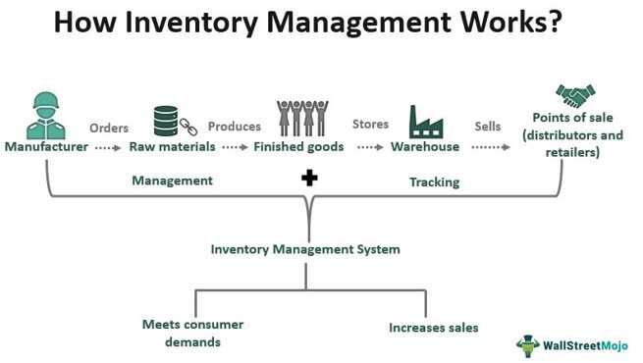



Here explanation of this flowchart;

* **Manufacturer** starts the process by **ordering raw materials**.
* The raw materials are used to **produce finished goods**.
* These goods are then **stored** in a **warehouse**.
* From the warehouse, products are **sold to distributors or retailers** at various **points of sale.**
* Throughout the process, there is continuous **managemen**t and **tracking**.
* An **inventory management system** helps balance supply with demand.
* This ensures that **customer needs are met** and **sales increase**, avoiding shortages or excess stock.

### **1.4.1 Types of Inventory**

Inventory is divided into different types based on how it's used or managed:

1. **Cycle Stock** – This is the regular inventory businesses keep on hand to support daily operations.
2. **Safety Stock** – Extra inventory kept as a backup to protect against unexpected shortages or fluctuations in demand.
3. **Seasonal Stock** – Products that are expected to be in higher demand during specific times of the year, like holiday items.
4. **Dead Stock** – Items that aren’t selling or have become outdated and no longer have demand.

### **1.4.2 Challenges in Inventory Management**

Managing inventory effectively can be tricky due to several common challenges:

**Demand Variability** – Customer demand often changes without warning, making it hard to keep just the right amount of stock.

**Supply Chain Disruptions** – Delays from suppliers or transport issues can slow down inventory movement and impact business operations.

**Inaccurate Forecasting** – When future demand isn’t predicted correctly, businesses may end up with too much inventory or run out of stock at the worst time.

## **1.5 Theoretical Models of Inventory Management**

Several mathematical models are used in inventory management to optimize stock levels:

### **1.5.1 Economic Order Quantity (EOQ)**

A formula used to determine the optimal order quantity to minimize the total cost of inventory.

**Formula:**

$EOQ= \sqrt{\frac{2DS}{H}}$

***​​***

**where:**

**D** = Demand rate

**S** = Ordering cost per order

**H** = Holding cost per unit per year

### **1.5.2 Just-in-Time (JIT)**

Inventory system aimed at reducing in-process inventory and associated costs by receiving goods only when needed. This system minimizes inventory holding costs by receiving goods only as they are needed in the production process, thus reducing waste.

### **1.5.3 Reorder Point (ROP)**

The inventory level at which a new order should be placed. ROP indicates when a new order should be placed to avoid stockouts during the lead time.

**Formula**:

$$ROP=(d×l)+Safety Stock$$

**Where:**

$d$**:** Average daily demand

$l$**:** Lead time (in days)

### **1.5.4 ABC Analysis**

A categorization technique that divides inventory into three classes (A, B, and C) based on their importance and value to the business. This helps prioritize management efforts on the most crucial items.

**Method:**

**A items:** High Value, low quantity (~70% value, ~10-20% items)

**B items:** Moderate value and quantity (~20% value)

**C items:** Low value, high quantity (~10% value, ~50-60% items)

**Steps:**

1. Calculate Annual Usage Value for each item:
$$Annual Usage Value=Unit Cost ×Annual Demands$$

2. Sort items by descending usage value.
3. Calculate cumulative total and percentages.
4. Categorize into A, B, and C using Pareto Principle (80/20 rule).

## **1.6 Predictive Analytics in Inventory Management**

Predictive analytics in inventory management is like giving businesses a smart assistant that helps them figure out how much stock they’ll need in the future. It works by looking at past sales, buying trends, seasonal patterns, and even outside factors like holidays or the weather. With this information, it can predict which products are likely to sell more, when it’s the right time to restock, and how much inventory should be kept on hand. This way, businesses can avoid the risk of running out of popular items when customers want them most, and at the same time, they don’t end up storing too much extra stock that just takes up space and wastes money.

**Example:** If a store notices umbrellas sell more in rainy month, predictive analytics can suggest ordering more before the next rainy session.

## **1.7 Support of Predictive Analytics in Inventory Management**

By optimizing the flow of information and goods predictive analytics supports inventory management. Here’s the process shown:

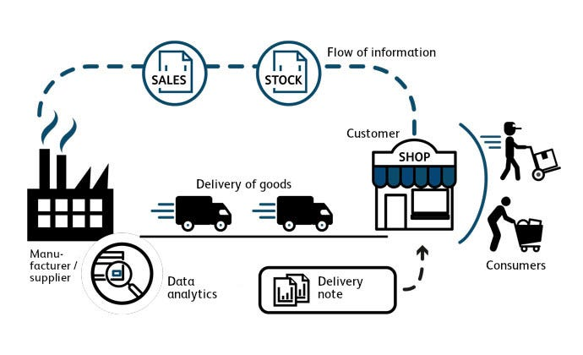

**1. Sales and Stock Data Collection**

**Sales** and **stock data** are the starting point for inventory planning. They help businesses understand past trends, product performance, and what customers are likely to want next.

**2.** **Flow of Information**

The sales and stock data shared with the manufacturing units or suppliers. This flow of information helps them make informed decisions about future production and when to restock, ensuring they meet demand efficiently.

**3.** **Manufacturing/Production**

With the help of predictive analytics, manufacturers can plan exactly how much of each product to produce and adjust their production schedules based on expected demand. This helps ensure they’re always making the right amount at the right time.

**4.** **Delivery to Stores**

The products are then delivered to stores or retail outlets, making sure they arrive on time. This ensures that shelves are stocked with the right items, just when customers expect them, based on the forecasted demand.

**5.** **Shop and Customer Interaction**

Customers buy the products they need, and their purchasing behavior is recorded. This data is then fed back into the system, completing the loop and helping the system learn and improve for future predictions.

**6.** **Prediction System**

At the core of everything is the "Prediction System." It uses past sales data, seasonal patterns, and even external factors like weather or events to predict future demand. Based on these insights, it helps businesses decide what actions to take, like when to order more stock or adjust production.

**Summary**

This cycle ensures:

* Reduced stockouts (empty shelves),
* Avoidance of overstock (which ties up money),
* Better customer satisfaction,
* Efficient inventory flow from production to end customer.

## **1.8 Role of Prediction in Inventory Management**

Inventory prediction involves forecasting future demand for products, which helps in planning inventory purchases. Predictive Analytics is a technique that uses data and algorithms to forecast future demand for products in inventory management. Various models such as time-series analysis, exponential smoothing, and regression analysis are used in inventory forecasting.

* **Time Series Analysis**: Utilizes historical data to predict future values.
* **Regression Analysis**: Finds relationships between product sales and influencing factors.

## **1.9 Importance of Predictive Analytics**

At its core, inventory is a straightforward idea — storing goods for future use. But if you take a closer look, you’ll discover there’s a dance between supply and demand, where timing is key.

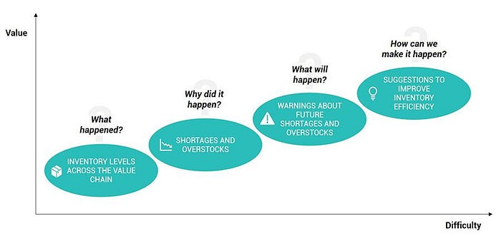

*Why Predictive analytics importance in Inventory management?*

Inventory goes beyond just a warehouse filled with products; it’s the heartbeat of modern business.

* **Move too slowly, and you face outdated stock and missed opportunities.**
* **Move too quickly, and you grapple with excess supply and higher holding costs.**

Similar to how a heartbeat must be steady and responsive, so should inventory management. Yet, as a human heartbeat adjusts with activity — speeding up during a sprint and slowing down during rest — inventory management also needs to be flexible. It must foresee market surges, identify lulls, and react with precision. This is the very essence of inventory — constantly changing, adapting, and keeping in sync with the market’s rhythm.

**Example:**

Let’s see what can predictive analytics be used for:

**Consider this scenario:** A retail store wants to know how many units of a popular product to stock for the upcoming holiday season. Predictive analytics takes into account past sales data, seasonal trends, and other relevant factors to forecast the expected demand accurately. Let’s break down how it works with a simple example:

**Imagine you have two stores:** **“Store One”** and **“Store Two”** both selling the same product — a leather jacket. Initially, each store had 9 jackets. After about a week of sales, the situation changes. **“Store One”** is running low on jackets due to high demand, while **“Store Two”** has less demand and needs to reduce prices to sell the jackets. Here’s a snapshot:

* ***“*Store One” needs more leather jackets.**
* **“Store Two” has extra jackets.**

Looking at this, it’s clear that moving 4 jackets from **“Store Two”** to **“Store One”** would fulfill all the orders. At this point, any action by the retailer is reactive. Customers have already turned to competitors, and moving inventory won’t undo the costs this problem created. The key is to avoid these costs proactively, and that’s where Business-Specific Predictive Analytics comes in. With the Inter-Store Balancing Solution, the system actively analyzes all factors in a retail supply chain and suggests the best schedule to transfer slow-selling products to stores where there’s high demand, preventing these issues before they occur.

## **1.10 Introduction to the Model**

In this project, the goal was to apply an **ABC analysis model** using 24 months of sales data to manage and predict inventory needs. The project applies Excel-based methods to analyze product categories based on revenue contributions and predict future demand.

## **1.11 Objective of the Model**

The objective of this model is Categorize inventory items based on their contribution to overall sales revenue using the **ABC Analysis techniques**. By analyzing historical sales data of 500+ products, the model aims to identify high-priority items (A-class), medium priority items (B-class), and low-priority items (C-class). This classification optimizing inventory management, reducing holding costs, and focusing managerial efforts on the most impactful products.

## **1.12 Dataset Overview**

The dataset used contains 500+ products, each with sales data for 24 months. For accuracy the first 3 months are historical sales data, while the remaining 9 months are used for forecasting. The data contains sales figures, product IDs, and prices.

## **1.13 Software Tool Used – Microsoft Excel**

Microsoft Excel is an ideal tool for this project due to its ability to:

* Organize and manage large datasets.
* Perform calculations with built-in functions like SUM, IF, VLOOKUP.
* Create charts and visualizations for better insights.

## **1.14 Benefits of the Project**

This project offers several key benefits for businesses, including:

* **Better Inventory Control** – Helping businesses keep track of their stock more efficiently.
* **Improved Forecasting** – Allowing businesses to predict demand more accurately.
* **Informed Decision-Making** – Empowering businesses with data to make smarter choices.
* **Avoiding Overstock and Stockouts** – Ensuring there’s neither too much nor too little inventory.
* **Continuous Supply of Goods** – Keeping shelves stocked and preventing shortages.
* **Cost Reduction** – Cutting down on unnecessary expenses related to inventory.
* **Improved Cash Flow** – Helping businesses manage their finances by reducing excess stock.

# **Chapter.No.02: ABC Analysis Model Using Excel**

**2.1 ABC Analysis**  
ABC analysis is a way to categorize products based on how much they contribute to a business's total revenue. Products are divided into three groups**:**

**A- Items**, which are high-revenue items that make up a small percentage of the total products (typically 70–80% of the revenue). **B-Items,** which bring in moderate revenue (about 15–25%) and **C-Items,** which are low-revenue products but make up a large portion of the inventory (usually the bottom 5–10%).

## **2.2 Theory Behind ABC Classification**

ABC Classification is a method used to prioritize inventory based on its value to the business. Products are divided into **three** categories: **A-Items,** are the most valuable, generating the highest revenue and requiring the most attention. **B-Items,** have moderate value; they are still important, but don’t demand as much focus as A items. **C-Items**, on the other hand, are low-value items that are less critical but may still be needed in bulk to meet customer orders.

**2.3 Use of ABC in Inventory**ABC analysis helps businesses prioritize their efforts. It focuses resources on high-value items and ensures that there is no overstock of low-value items, which could be a waste of capital.

## **2.4 Mathematical Calculations in ABC Analysis**

**2.4.1 Revenue Calculation**  
To calculate the revenue for each product, we multiply the quantity sold by the unit price:

$$Revenue=Quantity Sold×Unit Price$$

### **2.4.2 Percentage of Revenue and Cumulative Percentage**

After calculating the revenue for each product, we calculate its percentage of total revenue:

$$Percentage of Revenue=\frac{Revenue of Product}{Total Revenue}​×100$$

Then, we calculate the cumulative percentage by adding the percentages from each product in descending order of revenue.

**2.4.3 ABC Classification Formulae**Using the cumulative percentage, products are classified:

* **A Items**: Products contributing to 70–80% of total revenue.
* **B Items**: Products contributing to the next 15–25% of revenue.
* **C Items**: Products contributing to the last 5–10% of revenue.

Now, I will explain the process of performing **ABC Analysis** using **Excel**, step by step. The **ABC analysis** categorizes products based on their revenue contribution to identify which products to focus on in inventory management.

## **2.5 ABC Analysis Model Design**

Here, I will explain **each step** taken in the Excel model you followed to perform the analysis.

### **2.5.1 Introduction**

This chapter explains how an ABC Analysis model was built using Excel to manage inventory efficiently. The model uses sales data from over 500 products, including actual and forecasted data, to classify products into A, B, or C categories based on their revenue contribution.

### **2.5.2 Data Collection**

The first step in the process was **collecting the sales data** for the 500+ products over;

- Time Period: 24 months  
- Products: 500+ unique items  
- Sales History Used: 3 months  
- Forecast Used: 9 months  
- Total Period Analyzed: 12 months

### **2.5.3 Sales Forecasting and Data Preparation**

3 months of historical sales data was selected for accuracy. 9 months of forecasted data was added to create a complete 12-month dataset. Forecasting was done using Excel trendlines and estimates based on past trends.

### **2.5.4 Total Sales Column**

To calculate 12-month total sales for each product, we used:

**Formula:**

$$=SUM(N3:Z3)$$ (Assuming columns N to Z hold 12 months of sales data for a product in row 3)

### **2.5.5 ABC Analysis Strategy**

ABC Analysis groups products into three categories:

**A items:** Top 70–80% revenue (few high-value items)  
**B items:** Next 15–20% revenue  
**C items:** Remaining 5–10% revenue (many low-value items)

This helps in managing inventory by focusing on important items.

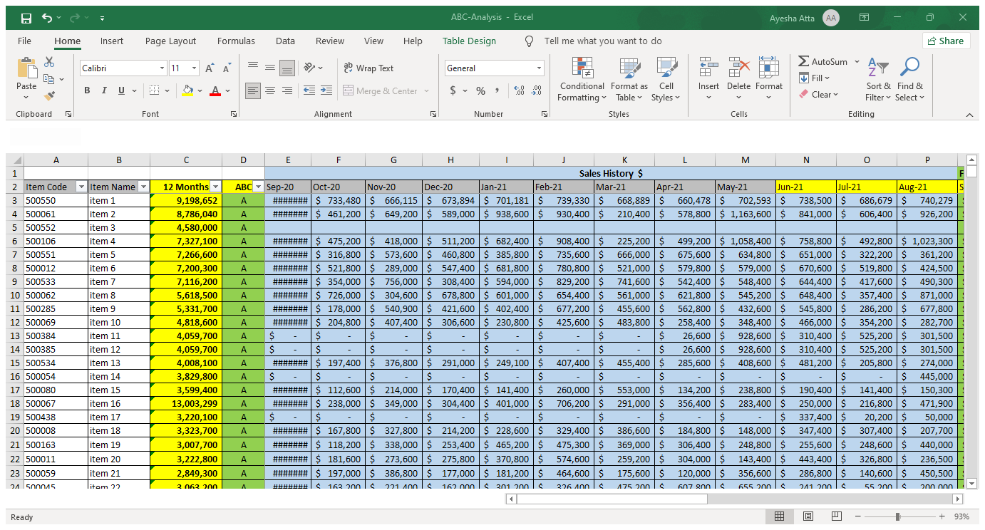

### **2.5.6 Excel Steps and Key Formulas**

After Data Preparation, Then Make table by selecting these columns;

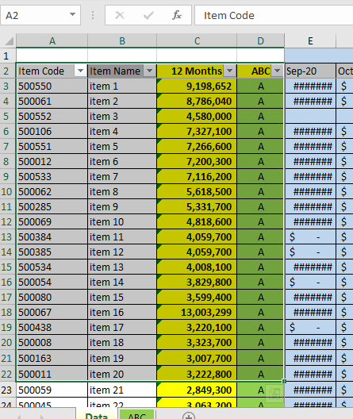

**Steps:**

1. Columns created:  
 - Product ID  
 - Product Name  
 - 12-Month Sales Total  
 - ABC Classification

2. Used structured table “**Ctrl + T”** for dynamic range reference.

### **2.5.7 Create Pivot Table**

Select the Table that we make and then,

Go to tab **Insert** > **Pivot Table** > **OK**

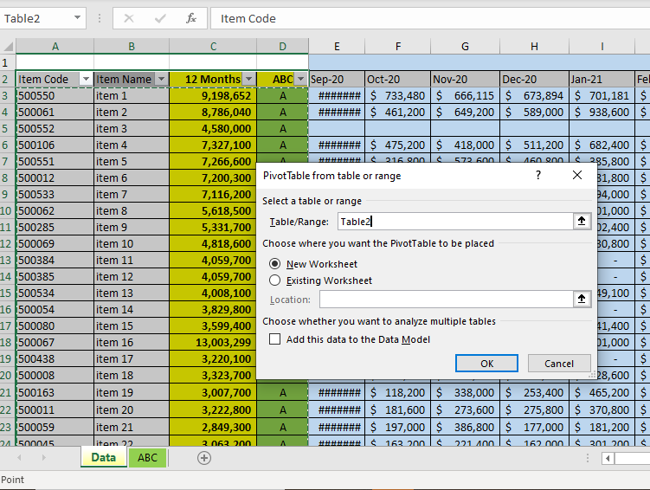

### **2.5.8 Pivot Table and Revenue Calculation**

After click “OK” then appear this type of layout in another Excel sheet;

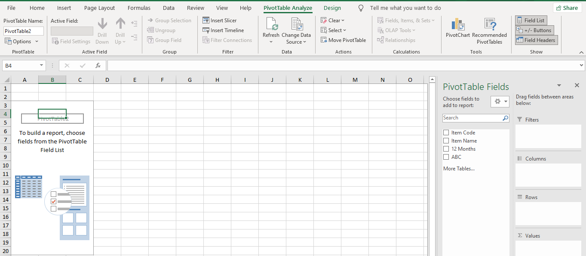

Inserted a Pivot Table  
- Dragged **Product ID** and **Product Name** to Rows.  
- Dragged **12-Month Sales** to **Values**.

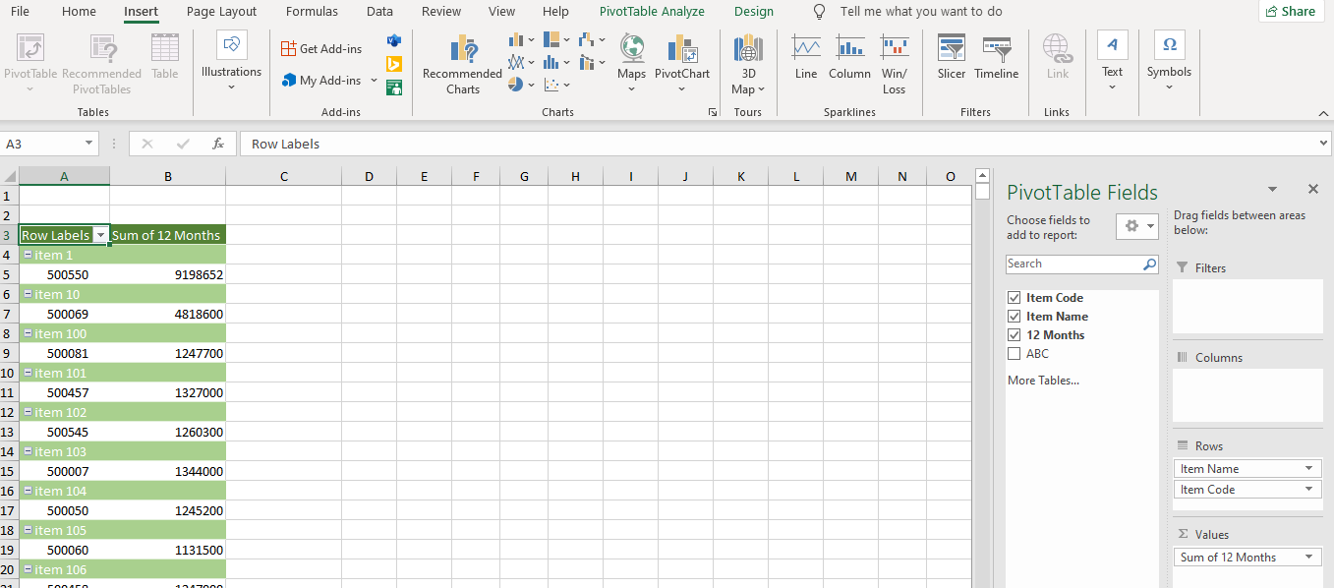

Then, Go to Tab **Design** > **Report Layout** > **show in Tabular Form**.

Then, sorted **12-Month Sales** in descending order: $$=SORT (A3:D501, 3, -1)$$

After this added new column before the previous columns and named as **Rank**.

Then, Used Pivot Table to sort and rank products by revenue.

Then, we calculated:  
- Percentage of Revenue by using Formula;

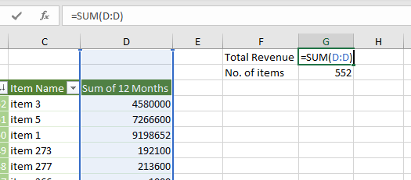

- Percentage of items by using formula;

$$=COUNT(C:C)$$

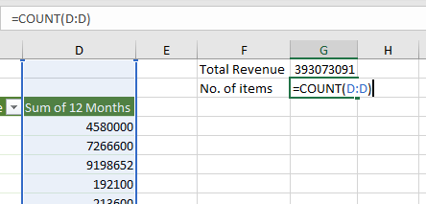

### **2.5.9 Calculating Percentage of Total Revenue**

After sorting, you needed to **calculate the percentage of total revenue** for each product. This step helps in understanding the revenue contribution of each product relative to the overall revenue.

**Explanation**: To find the percentage, the formula used in Excel was:

Then, we added columns for;

Calculated % of Revenue:

$$=\frac{Rank}{No. of items}×100$$**Formula in Excel:**

$$={D4}/{\$F\$1}$$

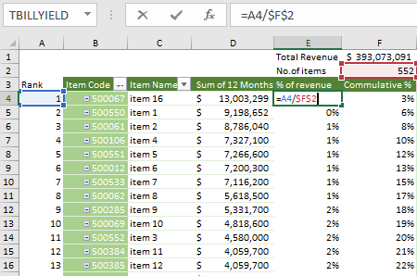

### **2.5.10 Calculating Cumulative Percentage**

Next, you calculated the **cumulative percentage** of revenue for each product. This is important because it helps in **categorizing** products into **A, B, or C** groups.

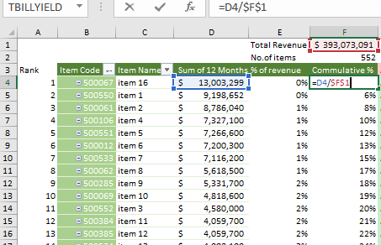

**Explanation**: The **cumulative percentage** shows how much of the total revenue is accounted for by the products up to a specific point.

* For example, after calculating the percentage for each product, you add each percentage to the previous one to get the cumulative value.

Calculate Cumulative Percentage;

$$=\frac{Revenue}{Total Revenue}$$

**Formula in Excel:**

$$={D4}/{\$F\$1}$$

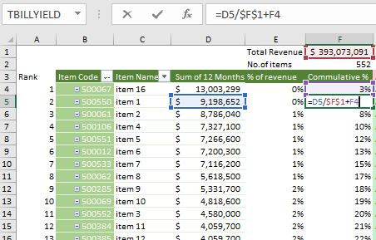

Cumulative Percentage for Product 1 = Product 1's Percentage  
Cumulative Percentage for Product 2 = Product 1's + Product 2's Percentage  
Cumulative Percentage for Product 3 = Product 1's + Product 2's + Product 3's Percentage.

* Repeat this process until the last product.

### **2.5.11 ABC Classification Formula**

Then make Table for classification of ABC items.

Where **K2** is the cumulative percentage of revenue.

**Explanation:**  
- If cumulative %, 40%, then A  
- If 80%, then B  
- Otherwise, C

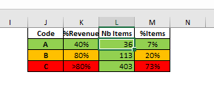

Then, we added one more Column named as ABC;

After calculating the cumulative percentages, you classified the products into **three categories**:

* **A Category**: Products that contribute to **70-80% of total revenue**.
* **B Category**: Products that contribute to the next **15-20% of revenue**.
* **C Category**: Products that contribute to the **remaining 5-10%**.

**Explanation**: This classification helps in focusing on high-revenue items, ensuring proper inventory management. The categories are based on the **cumulative percentage** you calculated in the previous step.

**Steps in Excel:**

1. Use an **IF ()** formula to assign a category based on the cumulative percentage:

**Formula in Excel: $$=IF (F4<=0.4,"A",IF (F4<=0.8,"B","C"))$$**

**OR,**

$$=IF(F4<\$K\$2, A, IF\left(F4<\$K\$3, B, IF\left(F4<\$K\$4, C\right)\right)$$

* **A Items**: Products with cumulative percentage less than 40%.
* **B Items**: Products with cumulative percentage less than 80%.
* **C Items**: Products with cumulative percentage between 40% and 80%.

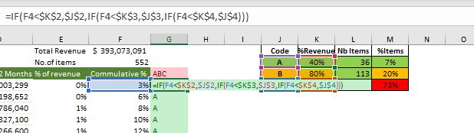

### **2.5.12 Creating and Analyzing the Line Chart**

The next step was to **visualize the ABC classification** results using Excel’s charting features.

**Explanation**: You created **line charts** to show the percentage of revenue and the number of items in each ABC category. This step makes it easier to understand the distribution of products across categories.

To show the result visually:  
1. Selected the **% of Revenue** and **cumulative %** columns.  
2. Inserted a **Line Chart**.  
3. Customized the **chart title**, **and labels**.

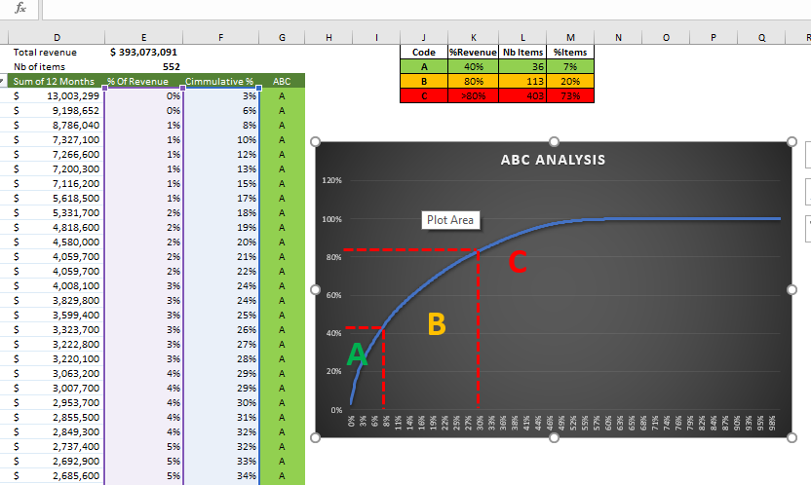

**Purpose:**  
- Shows how few items (A class) generate most revenue.

**What the chart shows:**  
- Steep curve for A items  
- Flattened curve for B and C items

### **2.5.13 Summary of steps**

This chapter explained how a complete ABC Analysis model was created in Excel. From combining sales data to forecasting, classifying, and visualizing product value—every step was done using Excel formulas and tools. This model helps businesses focus on key items and manage inventory more effectively.

Here’s a brief recap of the steps taken:

1. **Collected and organized sales data** for 500+ products.
2. **Sorted** the data by **Total Revenue**.
3. **Calculated the percentage** of total revenue for each product.
4. **Calculated the cumulative percentage** to identify the contribution of each product to overall revenue.
5. **Classified** products into **A, B, or C categories** based on their cumulative revenue percentage.
6. **Visualized** the results with pie charts for better insights.

**Reference:**

https://youtu.be/W1LHRXATmVw?si=eBP7Lls1rXTayMnE

# **Chapter.No.03: Results, Limitations, Comparison and Future work**

## **3.1 Results of the Model**

Your ABC analysis of over 500 products revealed some key insights about your inventory:

1. **The Vital Few (A-Items)**

These are 20% of your products (around 100 items), but they generate a massive 70% of your revenue**. For example,** your top-selling smartphone model is likely an A-item.

**Action Needed**: These items need to be closely monitored on a weekly basis because running out of stock can hurt profits.

1. **The Middle Ground (B-Items)**

These make up 30% of your inventory (about 150 items) and contribute around 20% of your revenue. **For example,** mid-range headphones might fall into this category.

**Action Needed**: Review these items monthly to ensure stock levels are appropriate and adjust as needed.

1. **The Trivial Many (C-Items)**

These are 50% of your products (around 250 items) but only bring in 10% of the revenue. An **example** might be inexpensive phone chargers.

**Action Needed**: Order these in bulk quarterly to save time and reduce manual work.

* **Real Impact**:

- You identified 23 slow-moving C-items that you can stop ordering entirely, freeing up space and resources.

- You also found 5 A-items that are so crucial to your revenue, they need extra safety stock to avoid any stockouts.

**Key Takeaway**:  
- Focus 80% of your time on managing just 20% of your products (the A-items) that drive the most value.

## **3.2 Purpose and Benefits (Why ABC Analysis)**

### **3.2.1 Uses of ABC Analysis**

ABC analysis helps you work smarter, not harder, by answering one key question:  
"Which few products bring most of my profits, and which ones just take up space?"

**Key Benefits:**

1. **Focus Where It Matters**  
   Instead of treating all products the same, you now have a clearer focus on where to invest your time and resources.

* **A-items** (20% of your products) bring in 70% of your revenue, so these need to be checked weekly to avoid stockouts.
* **C-items** (50% of your products) only contribute 10% of your revenue, so you can stop overordering them and focus on more important stock.

1. **Save Money**  
   Before, you were wasting money on stocking 100 cheap cables (C-items) that barely sold. Now, you can invest more in high-profit A-items, like laptops, that customers actually want.
2. **Save Time**  
   By spending less time managing low-value items, you can focus more on customer service and other important tasks.
3. **Fewer Stock Emergencies**  
   You can avoid unexpected "out of stock" situations with your bestsellers (A-items), keeping your top products available when customers want them most.
4. **Better Decisions**  
   With clear data, you no longer have to guess what to order—everything is based on solid insights.

**3.2.2 Real-Life Example**  
A small electronics store applied ABC analysis and achieved impressive results. They reduced excess stock by 30%, cut 5 hours per week spent on inventory management, and increased sales of their A-items by 15%.

**Key point:** ABC analysis acts like a spotlight, showing you exactly where to focus, allowing you to make more money with less effort.

## **3.3 How Model was Built**

You created this powerful tool in Excel with just 4 straightforward steps:

1. **Gathered Data**

Built this powerful tool in Excel using just four simple steps. First, you gathered your data. This included three months of actual sales data—**from June to August 2021**—along with nine months of sales forecasts covering **September to May 2022**. Altogether, the model worked with data from over **500 products** in your inventory.

1. **Calculated Key Numbers**

After gathering data then calculates:

**Total Revenue per Product:**

$$=SUM( sales june to May) // Add up 12 month$$

**Percentage of Total Revenue: $$=(Product Revenue / Total Revenue) × 100$$**

1. **Sorted & Classified**

Next, you sorted all the products from **highest to lowest** based on the revenue they generated. Then, using a simple Excel formula,

$$=IF(Cumulative\% ≤ 70\%,"A",IF(Cumulative\% ≤ 90\%,"B","C"))$$

you applied the ABC rule to classify them: products making up the first 70% of total revenue were labeled as **A-items**, the next 20% as **B-items,** and the remaining 10% as **C-items**.

1. **Made It Visual**

Finally, you brought the data to life with a Pivot Chart. It clearly showed the ABC categories using colors—A-items, which generate 70% of the revenue, were marked in **green** to highlight their **high priority**. B-items, making up 20% of the revenue, appeared in **yellow** as **moderate priority**. And C-items, contributing just 10%, were marked in **red** to indicate **low priority**. This made it easy to see where to focus at a glance.

**Why This Works:**

This method fits perfectly into your workflow because it uses the Excel skills you already know. There's no need for coding or any pricey software. Best of all, it takes less than an hour to update each month.

**Key Point:** Press “**Ctrl + T”** in Excel to turn your data into a table that auto-expands when you add new products—saving even more time!

## **3.4 Insights from ABC Categories**

Your ABC analysis reveals exactly how to manage each group for maximum profit:

### **3.4.1 A-Items (The VIP Products)**

These are the top performers—about 20% of your products, like best-selling laptops, that bring in the majority of your revenue. The key insight here is simple but powerful: even one stockout can put up to 70% of your revenue at risk. To avoid that, make sure you check their stock every week and have at least two reliable suppliers lined up as a backup. These are your VIP items, and they need extra attention.

**3.4.2** **B-Items (The Steady Performers)**  
These make up around 30% of your products—things like mid-range headphones. They don’t bring in as much revenue as your A-items, but they still matter. They’re not urgent, but they shouldn’t be overlooked either. A smart approach is to review them monthly and look for chances to bundle them with A-items. It’s an easy way to boost their sales while keeping them in check.

### **3.4.3 C-Items (The "Let It Go" List)**

These make up about 50% of your products—like cheap phone cables—but they don’t bring in much profit. In fact, they often take up most of your shelf space while contributing very little to your revenue. The smart move is to order them just once a quarter in bulk to save time and effort. And if you’ve got old stock piling up, run “Buy 1 Get 1 Free” deals to clear it out quickly.

**Real Impact You’ll See**

* 30% less time wasted on low-value items
* 20% fewer stock emergencies on your money-makers

**Key point:** Set Excel alerts when A-items hit reorder level:

$$=IF(Stock <= Reorder_Point, "ORDER NOW", "OK")$$

## **3.5 Limitations of the Model**

While your Excel-based ABC tool is powerful, it does come with a few things to watch out for.

**1. Not Real-Time**  
One downside is that it works with past data—usually last month’s—so it can miss sudden spikes in demand. For example, if sales suddenly jump during Diwali, your model won’t catch it automatically.

**Quick Fix**: Make it a habit to refresh your sales data every Monday. This simple step keeps your analysis up to date and more responsive to real-world changes.

**2. Ignores Hidden Costs**  
Another limitation is that the model doesn’t account for hidden costs behind the scenes. For example, storing C-items could be costing you ₹10 per item every month, and running out of A-items might mean losing valuable sales—neither of which shows up in your spreadsheet by default.

**Quick Fix**: Add simple notes or calculations in Excel.

$$C-item cost = Quantity × ₹10$$

For instance, multiply your C-item quantity by ₹10 to estimate storage costs. A little manual input can go a long way in revealing the bigger financial picture.

**3. No Seasonality Smarts**  
The model doesn’t account for seasonality, meaning it treats every month the same. For example, heaters might show up as low-priority C-items in the summer, but they’re actually A-items during the winter.

**Quick Fix**: Create seasonal versions of your ABC list. This way, you can adjust product priorities based on the time of year, ensuring you’re always on top of demand fluctuations.

**4. Supplier Surprises**

One issue with the model is that it doesn’t track if a supplier is frequently late with deliveries.

**Quick Fix**: Add a simple "Supplier Reliability Score" column in your spreadsheet, rating each supplier from 1 to 5. This will help you quickly spot potential issues and plan accordingly.

**5. Excel Headaches**  
A common issue is that the file may crash when you’re working with more than 1,000 products, making it hard to manage everything in one place.

**Quick Fix**: Split your data by category, like creating separate files for "Electronics_ABC.xlsx" or "Clothing_ABC.xlsx." This keeps things organized and reduces the chances of the file crashing.

* **Key Point:** Paste this checklist in your Excel file as a reminder!

## **3.6 Challenges & solutions**

**1. Messy Data**  
One challenge you faced was that the sales records had duplicates and missing entries, which made it difficult to analyze the data accurately.

**Fix**: You tackled this by using Excel’s **=REMOVE DUPLICATES** feature to clean up repeated entries and the **=IFERROR** function to handle missing data, ensuring everything was neat and reliable for analysis.

**2. Formula Errors**  
Another issue you ran into was that the **VLOOKUP** function would break whenever you added new products, causing errors in your data.

**Fix**: You switched to using **=INDEX-MATCH**, which is more flexible and handles new entries without causing any issues, making your formulas much more reliable.

**3. Slow Excel File**  
With over 500 rows of data, your Excel file started running slowly, which made calculations take forever.

**Fix**: You improved the speed by using **“Ctrl + T”** to turn your data into tables, which speeds up processing. You also split the data into separate categories, like creating an “Electronics” tab, making it easier to manage and faster to work with.

**4. Forecasting Guesswork**  
A challenge you faced was figuring out how to predict next month’s sales, especially when the numbers weren’t straightforward.

**Fix**: You kept it simple by using a trend formula:

$$Next Month = Last Month × 1.1 (if sales are growing).$$

This gave you a quick way to estimate future sales based on the previous month’s performance.

**5. Pushback**  
Sometimes, the team found the data a bit overwhelming and said, “It’s too complicated!”

**Fix**: To make things easier, you created a 1-page cheat sheet that broke it down into three simple steps for updating. You also added color-coded A/B/C examples, making it easy to understand and follow.

* **Key Point:** Keep a "Problem-Solution" log in Excel to track fixes!

## **3.7 Accuracy and Improvement Areas**

**Where Your Model Could Be Sharper;**

**1. Forecasting Errors**  
Right now, you’re using simple averages to predict sales, but this method can miss important trends and fluctuations.

**Fix**: A better approach would be to try Excel’s built-in $=FORECAST.ETS()$ function, which can provide more accurate, trend-based predictions and help you better anticipate future sales.

**2. Missing Cost Factors**  
Currently, your model only tracks revenue, but it doesn’t account for costs like product and storage expenses, which are key for understanding actual profit.

**Fix**: To fix this, you can add a new column with a simple formula: $$= (Revenue) - (Product Cost + Storage Cost).$$

This will give you a clearer picture of your true profit margins.

**3. One-Size-Fits-All Rules**  
Right now, your model applies the same reorder point to all A-items, but different products might need different levels of safety stock.

**Fix**: To improve this, customize reorder points for each product using a formula like: $$Safety Stock = MAX(10, Average Sales × 0.2)$$

This way, each product gets the appropriate level of stock to avoid shortages without overstocking.

* **Quick Wins You Can Add Today**

**Error Checker:** Add a new column with this formula to quickly spot any odd numbers in your data: $$=IF(Sales > 1000, "CHECK", "OK")$$

This will help flag unusually high sales figures that might need a closer look.

**Seasonal Adjustments:** To account for seasonal changes, create duplicate versions of your ABC list for different seasons, like summer and winter. This will ensure your stock levels align with seasonal demand shifts.

**Key Point:** Update your model every 3 months with fresh data to keep it accurate and relevant!

## **3.8 Comparison with Manual Inventory Methods**

**Manual Inventory Problems;**

**1. Guessing Game**  
Before, you were just guessing how many units to order—like saying, “Maybe order 50 units?” But, this often led to mistakes, such as stockouts of popular A-items and overstock of low-demand C-items.

**2. Time Drain**  
Managing inventory manually took up a lot of time—about 2 hours every week. And you were spending the same amount of time on low-value items, like ₹100 cables, as you were on high-value items, like ₹50,000 laptops, which wasn’t an efficient use of your time.

**3. No Priorities**  
Everything was treated the same—no clear distinction between high-demand and low-demand products. This made it harder to focus on what really mattered for the business.

**How Your ABC Model Fixes This;**

|  |  |  |
| --- | --- | --- |
| **Issue** | **Manual Method** | **ABC Model** |
| **Stock Decisions** | Gut feeling | Data-Driven (70-20-10 rule) |
| **Time Spent** | 8 hours/week | 1 hour/week |
| **Focus** | Scattered | Laser-targeted (A-items first) |

* **Real Example:**  
  **Manual:** Before, you experienced 12 stockouts every month.  
  **ABC Model:** With the new model in place, stockouts dropped to just 2 per month.
* **Key Advantage:**  
  The beauty of your model is that it automates the hard work, giving you clarity on exactly what to order and when. This makes inventory management much more efficient and helps avoid costly stockouts.

## **3.9 Comparison with Advanced Inventory Software**

|  |  |  |
| --- | --- | --- |
| **Feature** | **ABC Excel Model** | **Advanced Software (e.g., SAP, NetSuite)** |
| **Cost** | Free (Uses Excel you already have) | 5-10 lakh/year + implementation fees |
| **Ease of Use** | Simple (Basic Excel skills needed) | Complex (requires week of training) |
| **Real-Time Data** | Manual updates (refresh weekly/monthly) | Automatics 24/7 updates |
| **Best For** | Small business (<1,000 products) | Large warehouses or multi-location businesses |
| **Setup Time** | 1-2 days | 3-6 months |
| **Key Strength** | Fast, low-cost prioritization (A/B/C items) | End-to-end automation (orders, suppliers, etc.) |
| **Buggest Weakness** | No barcode scanning or supplier integrations | Overkill for small inventories |

**When to Switch:**  
Consider switching to the ABC model if:

* You’re spending more than 10 hours a week managing inventory.
* You’re expanding and opening a second store or warehouse.
* Your revenue has crossed ₹5 crore per year.

**Key Advantage:**  
Your ABC Excel tool does 80% of the work at no extra cost, making it the perfect solution for now! It's efficient, cost-effective, and scales with your business needs.

## **3.10 Future Work**

**1. Connect Excel to Live Sales Data**

**Problem:** Manual data entry takes up too much time.  
**Solution:** You can use Power Query, which is built into Excel, to automatically import sales data from your Point of Sale (POS) system and e-commerce platforms like Shopify or Amazon.  
**Benefit:** This will save you 3-5 hours a week on data updates, streamlining the process and making it much more efficient.

**2. Add Automated Alerts**  
**Problem:** You’re missing stockouts for A-items.  
**Solution:** Use a simple formula:

$$=IF(Stock <= Reorder_Point,"ORDER NOW","OK")$$

This will notify you when it’s time to reorder.

**Key Point:** You can also set up email alerts using VBA, which would take just about an hour to set up with a tutorial. This way, you’ll never miss an important restock again.

**3. Include Profit (Not Just Revenue)**  
Right now, your model only looks at how much money each product brings in—but not how much you actually earn from it. By adding one more column with this formula:

$$Profit = Revenue – (Product Cost + Storage Cost)$$

you can see the real picture. You might be surprised—some of your top-selling A-items could actually be eating into your profits once costs are included.

**4. Seasonal Adjustments**  
Your current model treats every month the same—but demand isn’t! For example, heaters might be top sellers in winter, while air conditioners lead in summer. The simple fix? Create separate ABC lists for each season. That way, your inventory always reflects what customers actually need—when they need it.

**5. Safety Stock Calculator**

**Current:** Guessing extra stock.  
**Better:** Add formula: $$Safety_Stock= (Max_Daily_Sales × Max_Lead_Time) - (Avg_Sales × Avg_Lead_Time)$$

**Example:** If max sales is 15 units/day and max delivery time is 10 days:

$$\left(15×10\right)-\left(10 ×7\right)=80 Units of safety stock$$

**6. Combine ABC + XYZ Analysis**

**XYZ:** Classifies items by demand stability:

|  |  |  |
| --- | --- | --- |
| **Type** | **Demand Variability** | **Action** |
| **X** | Steady (≤10%) | Order monthly |
| **Y** | Moderate (10-50%) | 15th of Month |
| **Z** | Unpredictable (>50%) | Order weekly |

**Formula In Excel: $$Variability = (STDEV.P(Monthly_Sales) / AVERAGE(Monthly_Sales))$$**

**7. Upgrade to Power BI (Later)**  
When your product list crosses 1,000 and Excel starts slowing down, it’s a good time to move to Power BI. It gives you live dashboards, smoother visuals, and mobile access—so you can monitor inventory on the go.